***PROJECT: 1***

**PRODUCT LANDING PAGE**

**TABLE OF CONTENTS:**

* INTRODUCTION
* HOME PAGE
* ABOUT PAGE
* CONTACT PAGE
* CHALLENGES FACED
* CONCLUSION
* OUTPUT

**PRODUCT LANDING PAGE: SUZUKI BIKES**

1. **INTRODUCTION:**

Welcome to the Suzuki Bikes product landing page, where innovation meets performance, and passion fuels every ride. Our website serves as your gateway to explore the exhilarating world of Suzuki motorcycles, renowned for their cutting-edge technology, legendary reliability, and uncompromising performance.

The Suzuki Bikes product landing page serves as an online platform to showcase Suzuki's range of motorcycles. It aims to attract potential customers, provide essential information about the products, and encourage user engagement. The website consists of three main pages: Home, About, and Contact.

At Suzuki, we believe in pushing the boundaries of what's possible, crafting motorcycles that not only excel on the road but also ignite the thrill of riding in every enthusiast's heart. Whether you're a seasoned rider seeking the ultimate adrenaline rush or a newcomer eager to embark on your two-wheeled journey, Suzuki has a bike tailored to your needs and aspirations.

**Discover the Suzuki Experience:**

As you navigate through our website, you'll encounter a seamless blend of captivating visuals, informative content, and user-friendly features designed to enhance your browsing experience. From the moment you land on our Home page, you'll be greeted by a mesmerizing display of our flagship Suzuki bikes, each beckoning you to embark on a journey of discovery.

**Explore Our Range:**

Delve deeper into our product lineup as you venture into the individual bike pages, where you'll uncover comprehensive details about each model's specifications, features, and performance capabilities. Whether it's the raw power of our sport bikes,

the versatile agility of our street bikes, or the rugged durability of our adventure bikes, there's a Suzuki motorcycle to match every rider's style and preference.

1. **HOME PAGE:**

* **Overview:**

The Home page is the first point of entry for visitors. It features an engaging design with high-resolution images and intuitive navigation to capture users' attention.

* **Bike Showcase:**

The centerpiece of the Home page is the showcase of three prominent Suzuki bikes. Each bike is accompanied by captivating visuals, brief descriptions highlighting key features, and a call-to-action button linking to the respective bike's page for more details.

* **Navigation:**

A navigation bar at the top provides easy access to other pages such as About and Contact. Additionally, a footer section contains links to social media platforms and important resources.

* **Responsive Design**:

The Home page is designed to be responsive, ensuring optimal viewing experience across various devices and screen sizes.

1. **ABOUT PAGE:**

* **Purpose:**

The About page provides detailed information about Suzuki's brand, history, and mission. It aims to establish credibility and build trust with potential customers.

* **Company Overview:**

This section provides an overview of Suzuki's history, highlighting key milestones, achievements, and core values.

* **Product Philosophy:**

Suzuki's approach to motorcycle design and innovation is explained, emphasizing factors such as performance, reliability, and rider experience.

1. **Contact Page:**

* **Contact Information:**

The Contact page features a contact form allowing users to submit inquiries, feedback, or requests for test rides. Additionally, essential contact details such as address, phone number, and email are provided for direct communication.

* **Dealer Locator:**

A feature to locate nearby Suzuki dealerships is included, enabling users to find convenient locations for purchasing or servicing Suzuki bikes.

1. **CHALLENGES FACED:**

* **Visual Design:**

Creating visually appealing designs that effectively represent Suzuki's brand identity while maintaining usability was a significant challenge. This required iterative design revisions and feedback from stakeholders.

* **Content Management:**

Curating and organizing content for the About page, including historical information and brand philosophy, required extensive research and coordination with Suzuki's marketing team.

* **Technical Implementation:**

Implementing responsive design principles and ensuring compatibility across various browsers and devices posed technical challenges during development. Thorough testing and optimization were necessary to address these issues effectively.

* **User Experience:**

Balancing aesthetic appeal with intuitive navigation and user-friendly interfaces to enhance the overall user experience was a continuous challenge throughout the development process. Feedback from usability testing helped identify areas for improvement and refinement.

* **Cross-Browser Compatibility:**

Ensuring that the landing page renders correctly across different web browsers (such as Chrome, Firefox, Safari, and Edge) can be challenging due to variations in how each browser interprets HTML and CSS code.

* **Page Load Speed**:

Optimizing the landing page's performance to minimize loading times is crucial for providing a smooth user experience. This involves techniques such as minimizing HTTP requests, optimizing images and multimedia content, and leveraging browser caching.

* **Accessibility:**

Ensuring that the landing page is accessible to users with disabilities, such as those using screen readers or keyboard navigation, requires adherence to accessibility standards.This involves considerations such as semantic HTML markup, proper use of ARIA attributes, and ensuring sufficient color contrast.

* **CSS Flexibility and Layout:**

Achieving complex layouts and designs using CSS can be challenging, particularly when dealing with intricate designs or unconventional layouts. This may require a deep understanding of CSS positioning, floats, flexbox, and grid layout systems**.**

* **Responsive Design:**

Designing a landing page that looks good and functions well on various devices and screen sizes (desktops, laptops, tablets, and smartphones) requires careful consideration of responsive design principles and techniques such as media queries and fluid layouts.

1. **CONCLUSION:**

In conclusion, while creating a product landing page using HTML and CSS offers numerous opportunities for creativity and innovation, it also presents several challenges for programmers. From ensuring cross-browser compatibility and responsiveness to optimizing performance and accessibility, developers must navigate a myriad of technical considerations to deliver a high-quality user experience. Additionally, maintaining code cleanliness, accommodating client requirements, and staying abreast of evolving web standards further compound the complexity of the task. Despite these challenges, a meticulous approach to coding, coupled with a commitment to continuous learning and adaptation, enables programmers to overcome obstacles and create impactful landing pages that captivate audiences and drive conversions. As the digital landscape continues to evolve, mastering the art of HTML and CSS development remains essential for building compelling and effective web experiences.

1. **OUTPUTS:**

**HOME PAGE:**

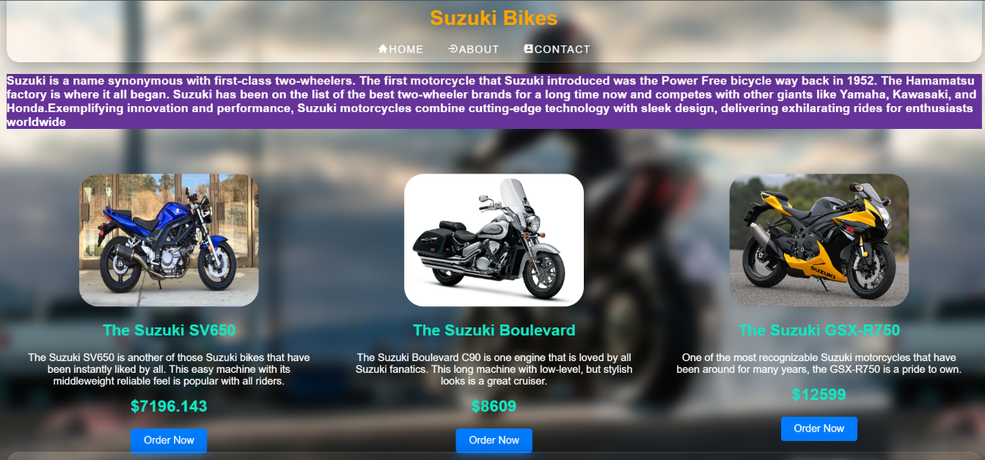

**ABOUT PAGE:**

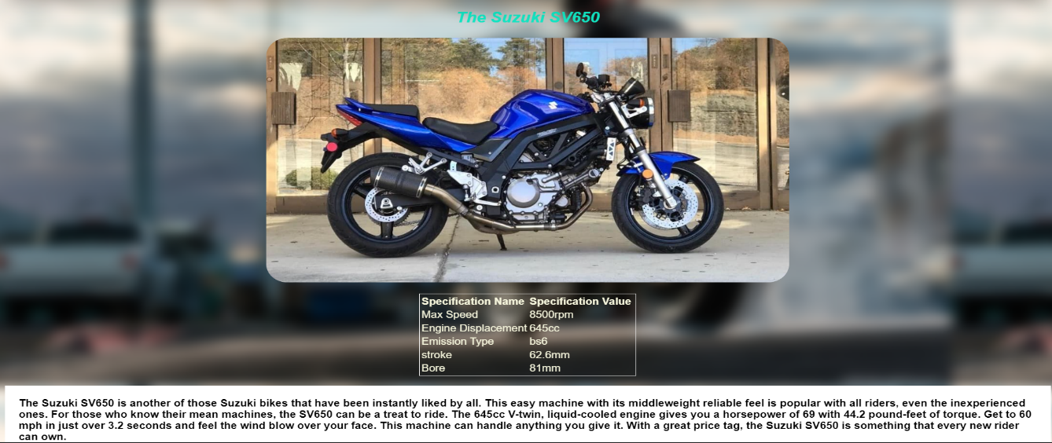

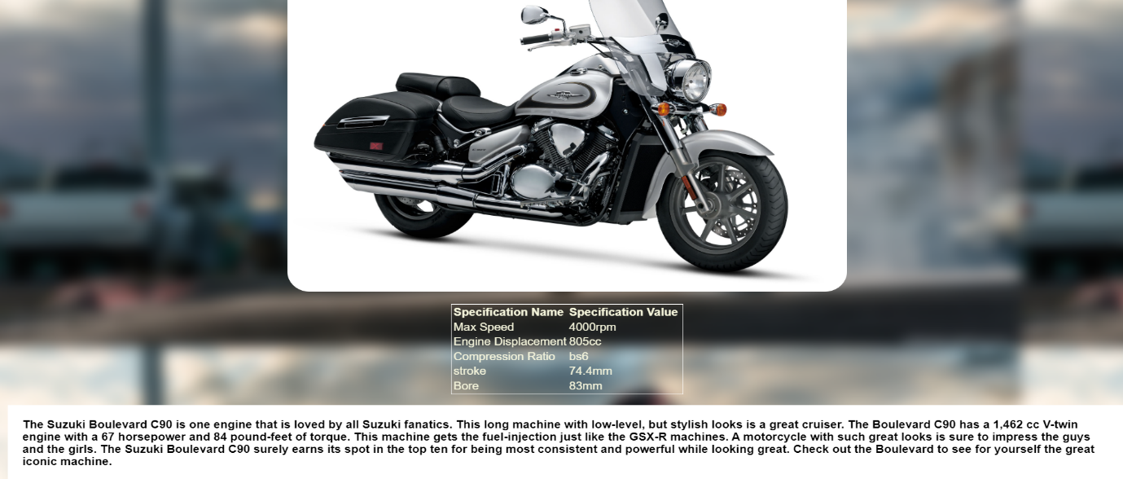

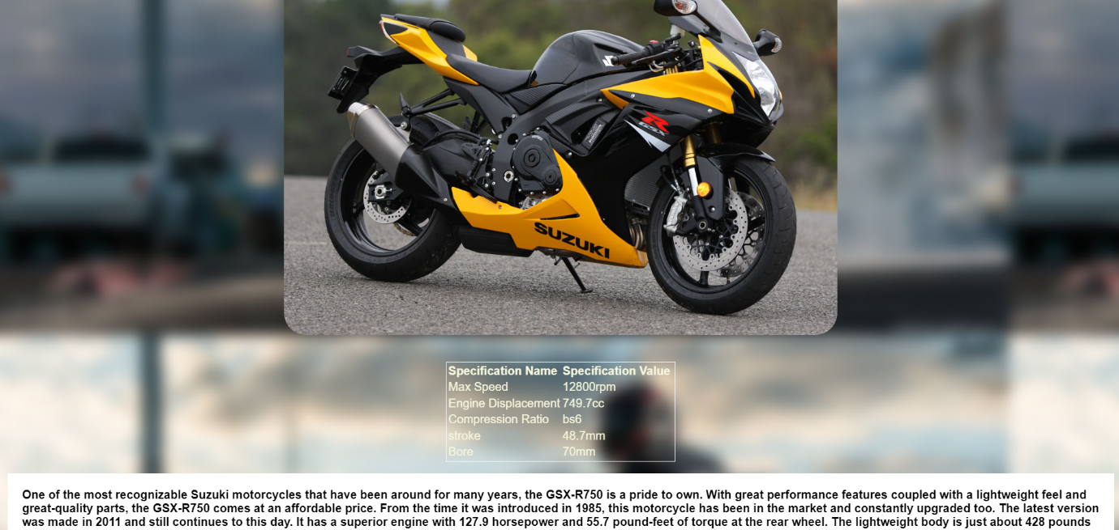

**CONTACT PAGE:**

